Practical 4:
Aim:
Add dynamic UI components such as collapsible FAQ, modal popup,
image/content slider, notification banner, hamburger menu, and light/dark
theme switcher using JavaScript.
Screenshots:
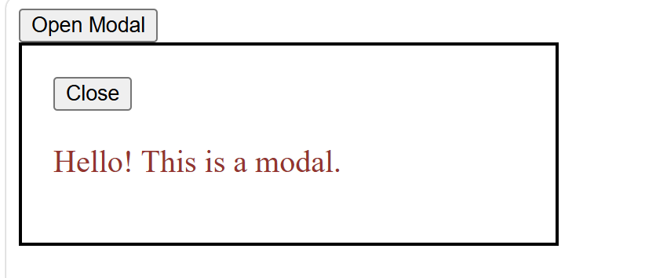





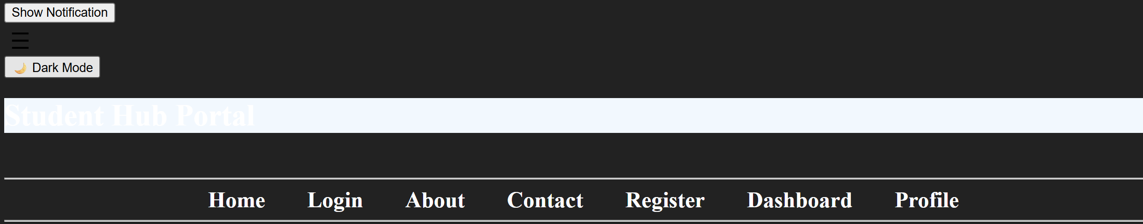

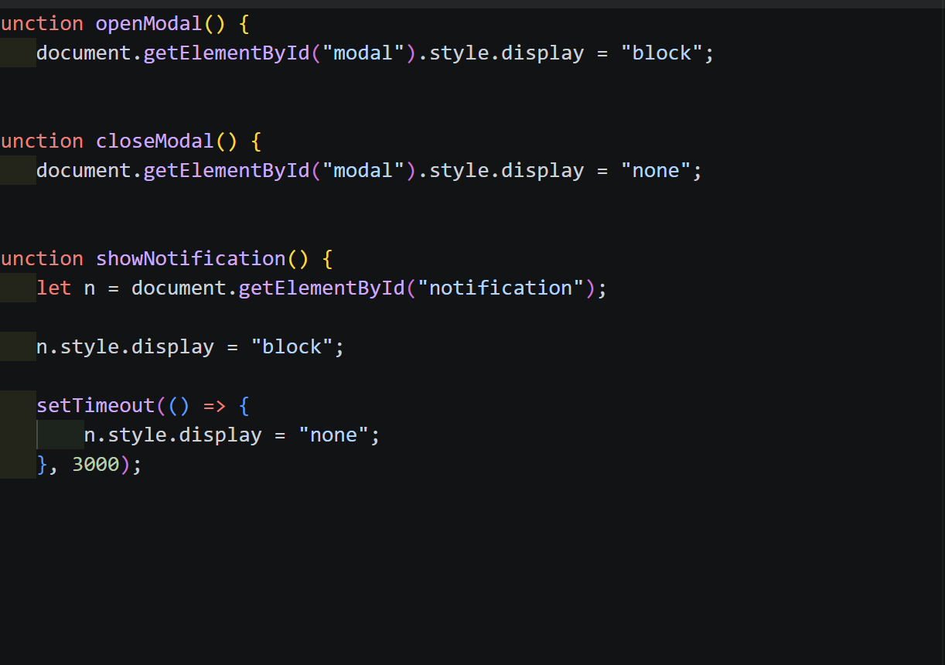
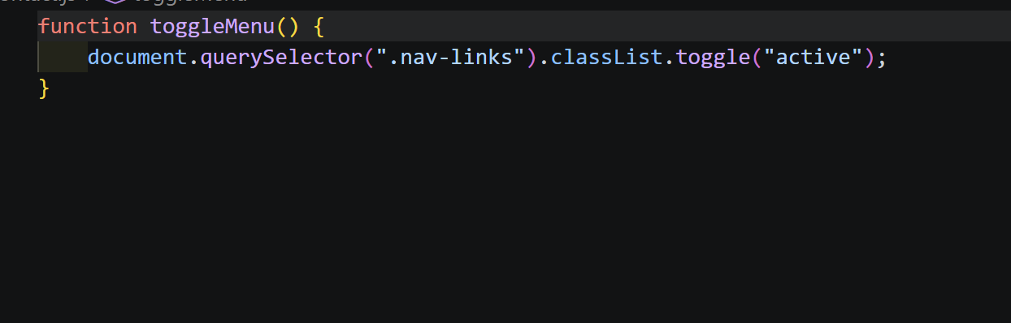

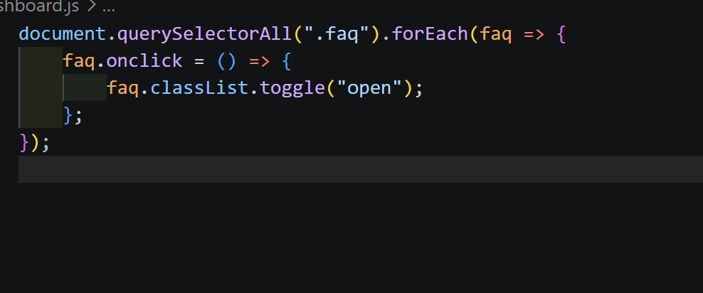
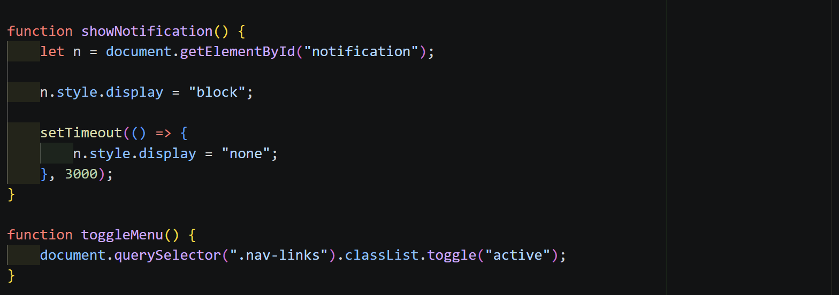
Learning:
Implementation of javascript in the webpages.

